DATABASE APPLICATIONS LAB

PROJECT

Title: E-commerce Database Management System.

Team Details:

Name | USN | Roll No
Sanskruti Agasgekar | 01FE24BCS169 | 333
Nivrutti Patil | 01FE24BCS168 | 332
Kedar Nimbalkar | 01FE24BCS159 | 323

Flow:

Problem Specification:
The proposed E-Commerce Database Management System is designed to manage online shopping activities by handling customers, sellers, products, orders, payments, and reviews efficiently. The system stores customer details such as name, email, phone number, date of birth, and a derived age, and allows each customer to have multiple addresses. Sellers are registered with basic details and can sell multiple products, while each product belongs to exactly one seller and one category. Product information includes product name, brand, MRP, and stock status, and categories are used to classify products. Customers can add products to a shopping cart, where item total and grand total are derived values. When a customer places an order, order details such as order date, shipping date, amount, and status are recorded. The OrderItem entity resolves the many-to-many relationship between orders and products by storing product-wise quantity and MRP. Payments made by customers are recorded with payment mode and date, and each payment corresponds to a single order. Customers can also submit reviews for products, including ratings and descriptions. The system maintains referential integrity using primary and foreign keys, avoids redundancy through derived attributes, and ensures a structured and normalized database design suitable for an e-commerce platform.

The Entity-Relationship (ER) Diagram:

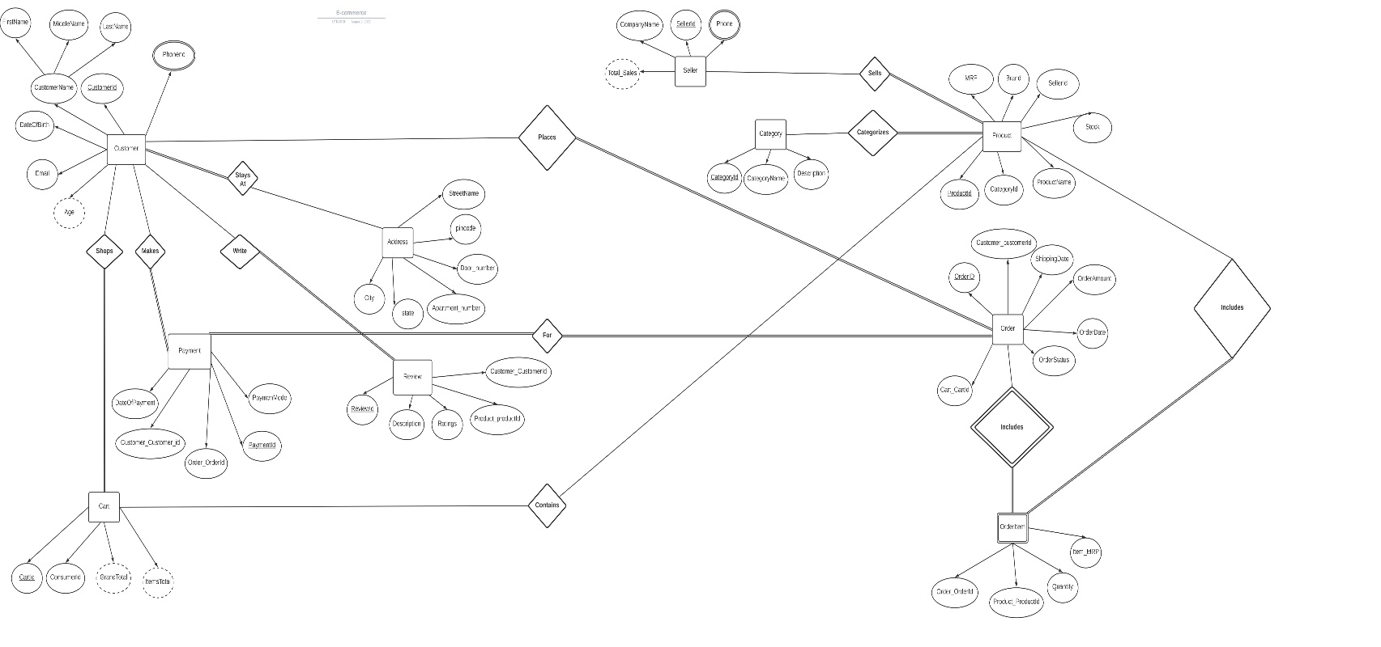

Relationship Schema:

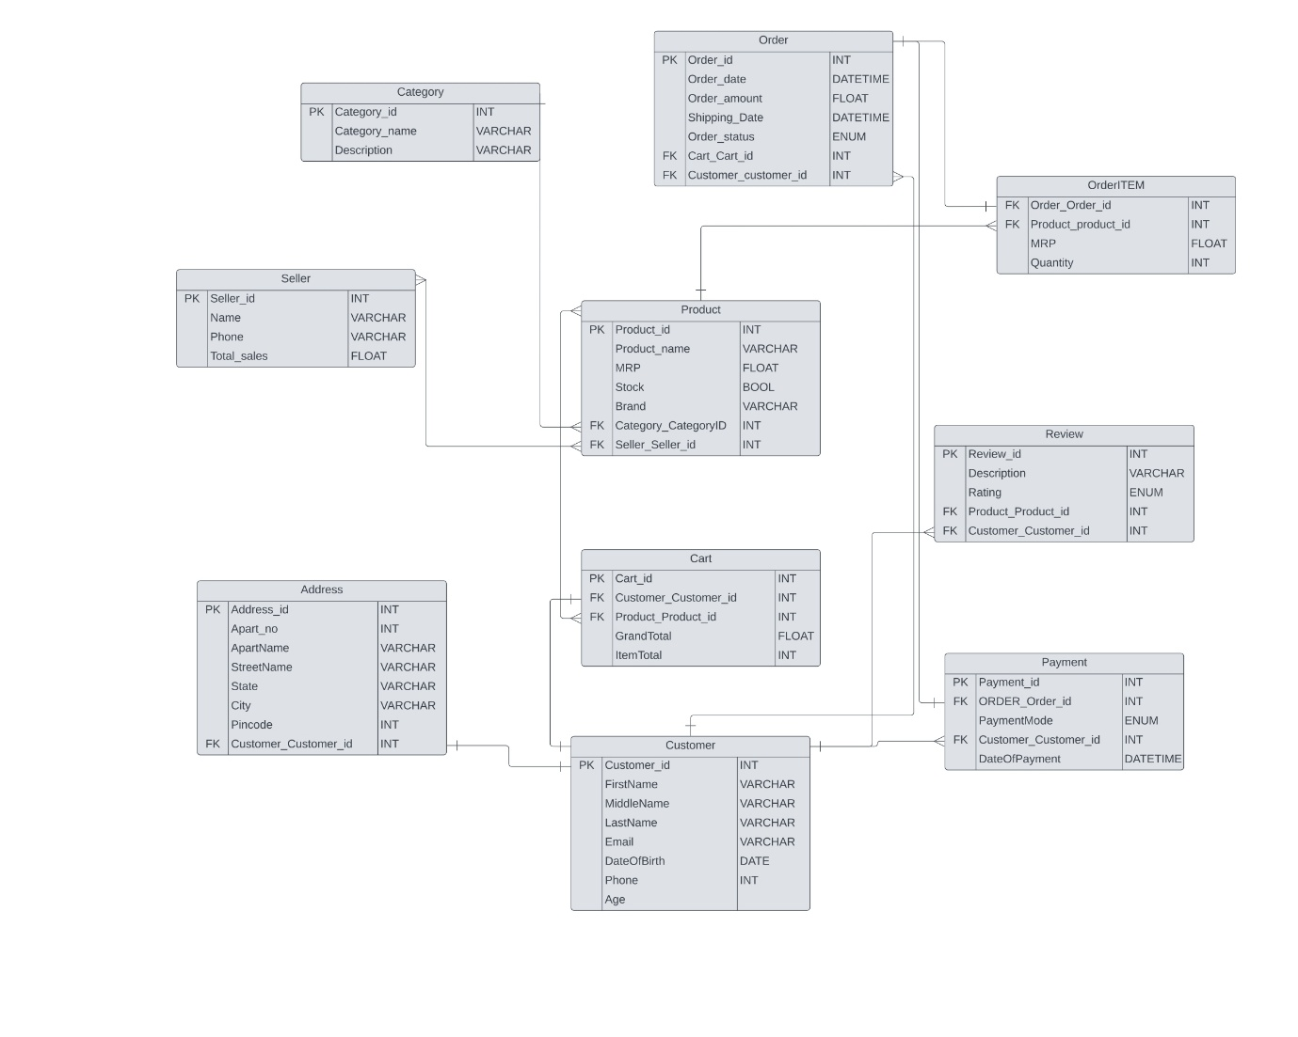
Github link:
https://github.com/E-commerce-Database-Project/E-commerce_Project

